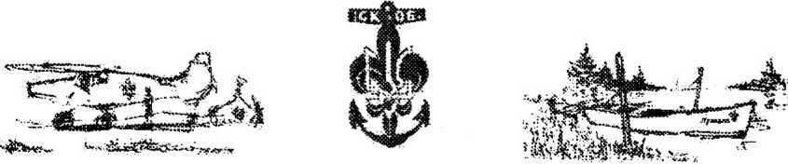

MT Safety Policy

1. Lifejackets must be worn during all water activities and whenever on or in the water (possible exception is swimming with lifeguard present).
2. No diving, no exceptions to this rule.
   1. No diving from boats;
   2. No diving from canoes;
   3. No diving from docks;
   4. No diving from shore;
   5. No diving from any other craft, device, platform, etc.
3. Helmets must be worn during all water activities.
   1. Exceptions to wearing helmets: swimming and when in the motorboat.
4. No person is allowed in the water without a designated partner (“buddy system”) and at least one certified lifeguard present (when sailing, kayaking, or canoeing, a designated partner, “buddy”, may not be required).
5. No camp participant1 is allowed in the water, allowed to operate boats (motorized or other), or allowed to use water equipment (e.g. canoes, kayaks, sunfish, tubes, rafts) between sunset and sunrise, unless for emergency purposes or authorized by the Captain.
6. In the case of lightning, all water activities must cease immediately and all persons must exit the water at once.
7. “Beware of the propeller”: When on a motorboat, waterskiing, wakeboarding, tubing, or any other activity that enables the use of the motorboat, every person must always be aware of the propeller and always maintain a safe distance from it.
8. Extreme care must be taken around and when handling Coleman lanterns, grills, stoves, gasoline, propane, and/or Coleman fuel.

# MT Camp Rules

1. Possession and/or use of alcohol, tobacco substances, narcotics, illegal drugs (including prescription drugs not being used for their prescribed purposes) is prohibited and will be reported to law enforcement authorities.
2. Camp participants1 are not allowed outside the boundaries of the camp grounds as defined by the Captain.
3. Males and females must keep to their respective and designated camping areas, unless escorted by a camp counselor.
4. There will be designated separate male and female bathrooms; males and females must only use their designated bathrooms – no exceptions.
5. Walking and/or running barefoot on the camp grounds is prohibited.

By *signing below, I have read and understood the above safety policy and camp rules.*

Type Here for Participant. Enter a date.

Camp Participant Date

Type Here to Sign. Enter a date.

Parent, Guardian Date

1 Camp participants exclude the counselors and staff